- \Operation\Tube blow out\Settings
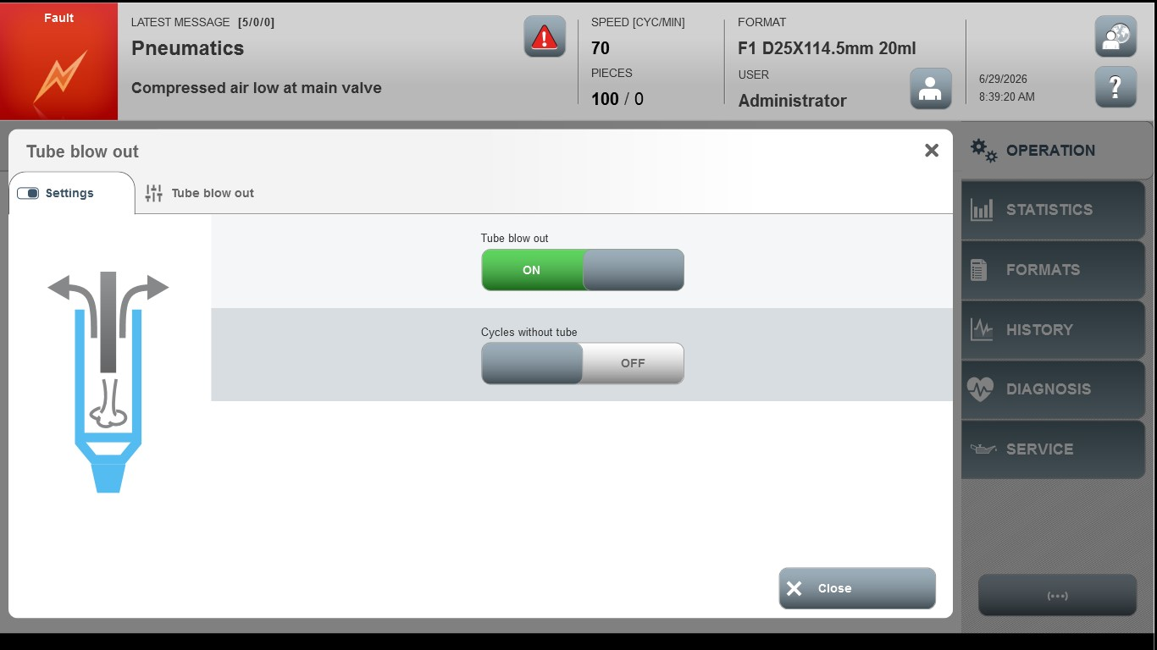
Acceptance criterion | Limits | Pass / Fail: Dev-No. | Date | Initials
Screen matches screenshot | N / A
Duration, blow impulse | 50 …. 1000

